NETWORK TRAFFIC CONTINGENCY PLAN
Document Title: Network Traffic Contingency Plan
Project: Cluster 6 – Darvycom Australia
Unit: ICTTEN615 – Manage Network Traffic
Prepared by: Leonardo Matias Ciarcia
Date: 03/02/2026
Version: 1.0

1. Purpose
The purpose of this contingency plan is to provide procedures for responding to unexpected network problems, congestion, failed configuration changes and equipment outages within the Darvycom Australia network.
The plan aims to reduce service disruption and ensure network services can be restored within an acceptable period.

2. Scope
This contingency plan applies to:
- Network routers
- Switches
- Servers
- Network links
- Internet services
- VPN services
- Voice services
- Wireless services
- Network monitoring systems
- Critical business applications

3. Possible risks
The following risks have been identified:
- Network congestion
- Router or switch failure
- Server failure
- Internet connection failure
- Configuration error
- Software upgrade failure
- Excessive packet loss
- High CPU utilisation
- Network interface failure
- Unexpected traffic increase
- Security-related traffic event
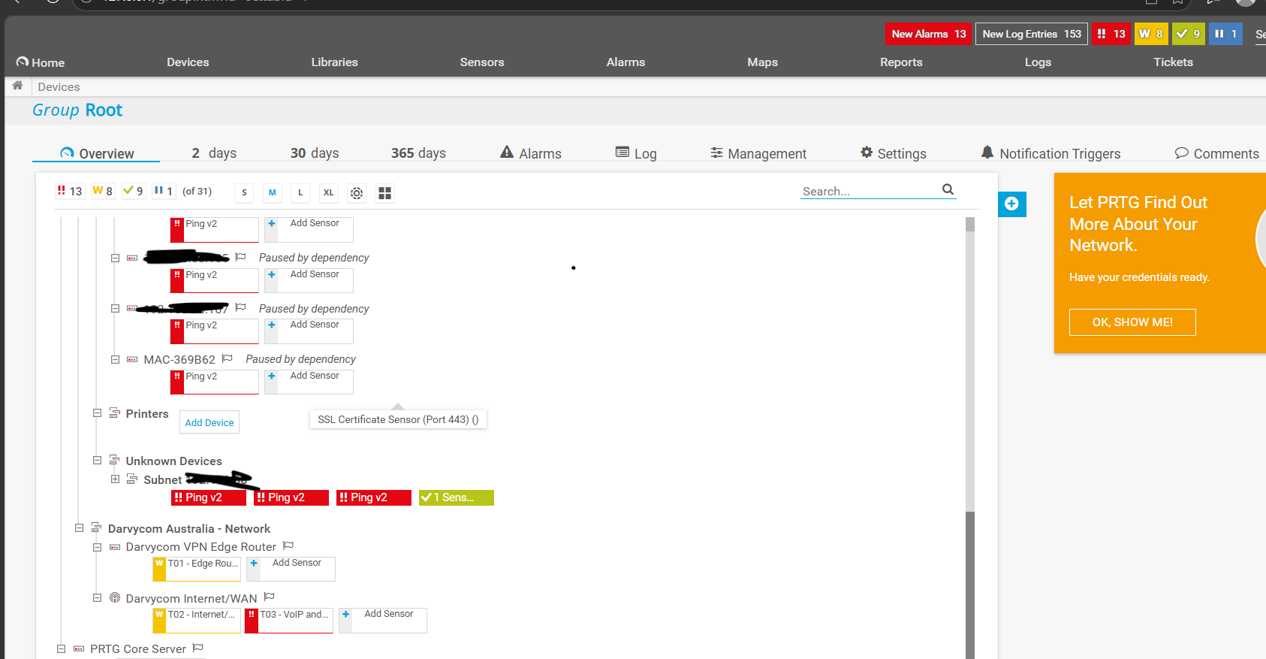
Sensor Down

4. Contingency triggers
The contingency plan may be activated when:
- PRTG reports a Down condition.
- Bandwidth exceeds the approved critical threshold.
- Packet loss reaches an unacceptable level.
- Network latency increases significantly.
- A critical device becomes unavailable.
- CPU or memory reaches a critical level.
- A configuration change causes loss of connectivity.
- Critical network services become unavailable.

5. Required resources
Resources required during an incident may include:
- PRTG Network Monitor
- Network administrator access
- Configuration backups
- Network documentation
- Spare network equipment
- Approved software packages
- Technical support personnel
- Emergency contact information
- Rollback instructions
- Alternative network connections
Resources should be prioritised according to the importance of the affected service.

6. Contingency response procedures

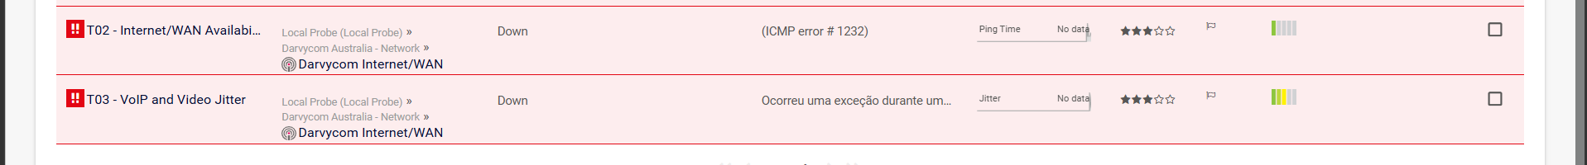

Alarm sensor down

Incident | Immediate action | Recovery action
Network congestion | Identify source using PRTG | Apply QoS, shaping or restrictions
Router or switch failure | Confirm failure using Ping/PRTG | Restart, replace or reroute
Configuration failure | Stop the change | Restore previous configuration
High packet loss | Identify affected route | Troubleshoot or use alternate path
CPU overload | Reduce unnecessary traffic | Optimise or upgrade device
Internet failure | Confirm route unavailability | Activate approved alternative connection
Software failure | Stop deployment | Restore previous software/configuration

7. Rollback and reversal procedure
Before major changes:
- Record the existing network configuration.
- Create a configuration backup.
- Confirm the rollback procedure.
- Obtain appropriate approval.
- Implement the change.
- Monitor the network with PRTG.
If the change causes unacceptable performance:
- Stop the implementation.
- Notify relevant personnel.
- Restore the previous stable configuration.
- Confirm connectivity using Ping and PRTG.
- Verify network services.
- Record the problem and corrective action.

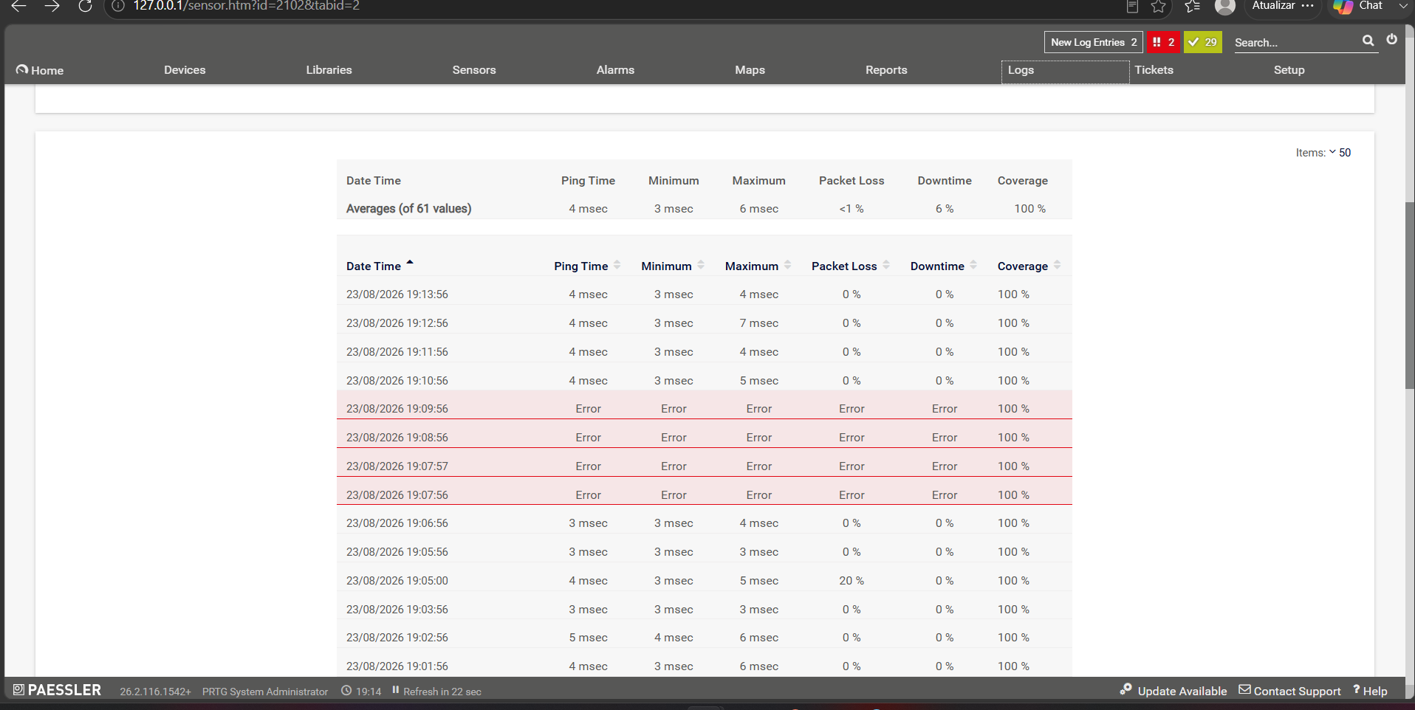
Sensor turning up

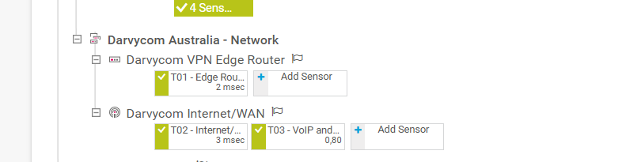
Sensor up

8. Roles and responsibilities
Project Manager / Technical Specialist
- Coordinate the response.
- Approve or escalate corrective actions.
- Communicate with stakeholders.
Network Administrator
- Investigate network faults.
- Apply technical recovery procedures.
- Restore configurations.
Relevant Management
- Approve major changes or additional expenditure.
- Receive incident and recovery reports.

9. Communication and escalation
During a major incident, relevant personnel should receive information about:
- Nature of the problem
- Affected services
- Actions being taken
- Estimated restoration time
- Final restoration status
- Recommended follow-up action

